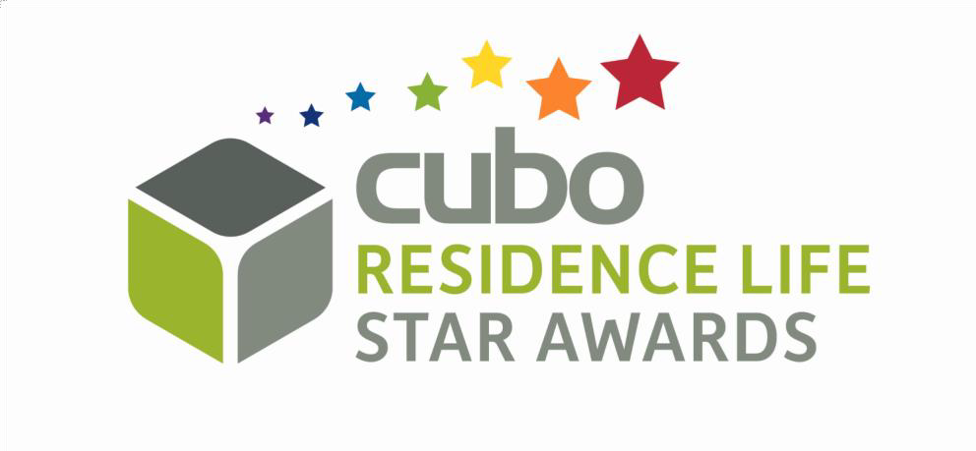
ENTRY FORM – CUBO & ACUHO – 1 NEW RESIDENCE LIFE PROFESSIONAL OF THE YEAR

RULES OF ENTRY
- Nominees must be professionals working in residence life roles in student accommodation in the UK or Ireland.

- Nominees must be nominated by their employer.

- Maximum two nominations per institution/PBSA organisation.

- Maximum 500 words per entry using the entry form provided.

- Entries must be submitted by Thursday 17 March 2022.

INSTITUTION/ORGANISATION:

NOMINEE NAME:

NOMINEE JOB TITLE:

- Please complete the following questions (500 words maximum in total).

- Please provide quantitative evidence where possible to support the objectives and statements provided.

- WHY DOES THE EMPLOYEE DESERVE RECOGNITION?

- WHAT HAS BEEN A NOTICEABLE ACHIEVMENT OF THEIRS?

- IN WHAT WAY HAVE THEY IMPACTED/BENEFITED/INFLUENCED THEIR COMMUNITY?

- WHAT DO COLLEAGUES/RESIDENTS HAVE TO SAY ABOUT THEM?

- WHAT OTHER EVIDENCE WOULD YOU LIKE TO SUBMIT TO SUPPORT THIS NOMINATION?

ENTRY SUBMITTED BY:

JOB TITLE:

EMAIL:

PHONE:

IF THE ABOVE NAME ENTRANT WINS AN AWARD, I AGREE THAT THE INFORMATION ON THIS ENTRY FORM MAY BE USED AS A CAREER CASE STUDY, AND THE ENTRANT’S NAME AND PHOTO CAN BE USED IN AWARDS PUBLICITY.

- PLEASE TICK THE BOX YES

CLOSING DATE IS THURSDAY 17TH MARCH 2022

